Summer Reading Challenge – Transition.
Lose yourself in a book! Here are some suggestions to keep you enjoying reading all summer long. How many can you read? Choose your book, click the link and read for free! Enjoy! Tell your English teacher about the books you have read and earn your first reward points!
Ink Heart - Cornelia Funke
Meggie loves books. So does her father, Mo, a bookbinder, although he has never read aloud to her since her mother mysteriously disappeared. They live quietly until the night a stranger knocks at their door. He has come with a warning that forces Mo to reveal an extraordinary secret - a storytelling secret that will change their lives forever.

https://novels80.com/2434314-inkheart.html

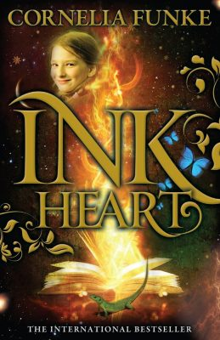

Harry Potter and the Philosopher's Stone
Harry Potter and the Philosopher's Stone is a fantasy novel written by British author J. K. Rowling. The first novel in the Harry Potter series and Rowling's debut novel, it follows Harry Potter, a young wizard who discovers his magical heritage on his eleventh birthday, when he receives a letter of acceptance to Hogwarts School of Witchcraft and Wizardry. Harry makes close friends and a few enemies during his first year at the school, and with the help of his friends, Harry faces an attempted comeback by the dark wizard Lord Voldemort, who killed Harry's parents, but failed to kill Harry when he was just 15 months old.
https://readanybook.com/online/634176

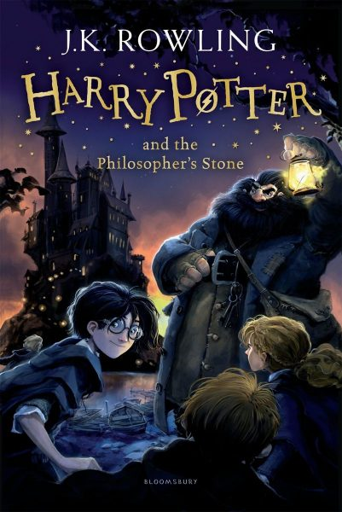

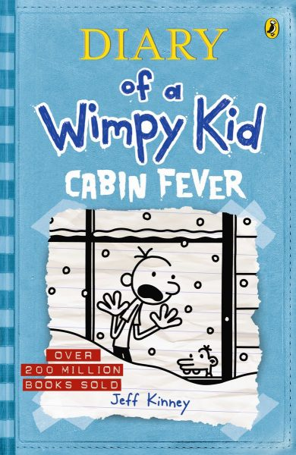
Diary of A Wimpy Kid Series – Jeff Kinney
Diary of a Wimpy Kid is a series of fiction books written by the American author and cartoonist Jeff Kinney. All the books are the journals of the main character, Greg Heffley. Befitting a teen's diary, the books are filled with hand-written notes and random drawings of Greg's daily adventures.
https://www.funbrain.com/books/diary-of-a-wimpy-kid/page/1

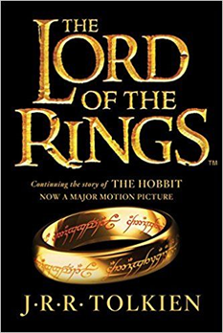
The Lord of the Rings - J. R. R. Tolkien. The Lord of the Rings is an epic high fantasy novel written by English author and scholar J. R. R. Tolkien. The story began as a sequel to Tolkien's 1937 fantasy novel The Hobbit, but eventually developed into a much larger work. Written in stages between 1937 and 1949, The Lord of the Rings is one of the best-selling novels ever written, with over 150 million copies sold. Whilst certainly a more challenging read, the popularity of last decade’s movies has made the characters and plot much more accessible.
https://novel12.com/242597/the-fellowship-of-the-ring.htm

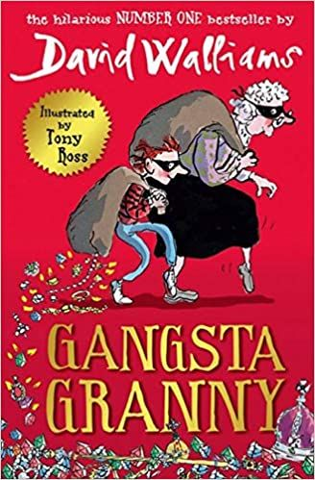
Gangsta Granny
David Walliams
Ben, a boy, hates having to stay with his Granny every Friday because his parents go to see a dancing show named "Strictly Stars Dancing". He finds it boring and repetitive as his Granny always feeds him cabbage-related dishes, most commonly cabbage soup and cabbage chocolate, and they are constantly playing Scrabble, plus her television hasn't been working since the 1990s.
https://readonlinenovel.net/book-reader/gangsta-granny

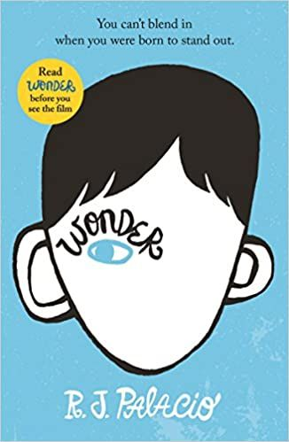
Wonder - R.J. Palacio
Auggie wants to be an ordinary ten-year-old. He does ordinary things - eating ice cream, playing on his Xbox. He feels ordinary - inside. But ordinary kids don't make other ordinary kids run away screaming in playgrounds. Ordinary kids aren't stared at wherever they go. Born with a terrible facial abnormality, Auggie has been home-schooled by his parents his whole life. Now, for the first time, he's being sent to a real school - and he's dreading it. All he wants is to be accepted - but can he convince his new classmates that he's just like them, underneath it all?
https://www.readingsanctuary.com/wp-content/uploads/2018/10/Wonder.pdf

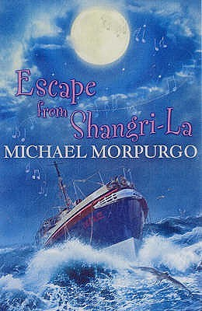
Escape from Shangri - La Michael Morpurgo
Cessie tried to help Popsicle to remember his past, but how can she help? She is just 11 years old and she doesn’t even know what happened… The only thing that Popsicle can remember is his family…

https://freeonlineread.net/book-reader/escape-from-shangri-la

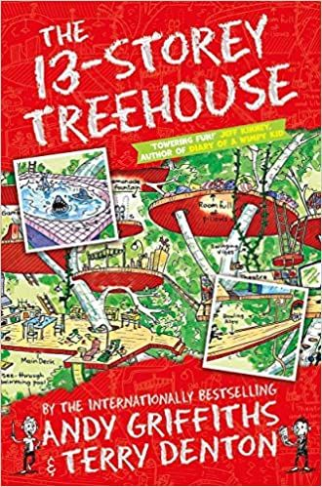
Treehouse series Andy Griffiths
Andy and Terry live in the WORLD'S BEST treehouse! It's got a giant caatapult, a secret underground laboratory, a tank of man-eating sharks and a marshmallow machine that follows you around and shoots marshmallows into your mouth whenever you're hungry! Just watch out for the sea monkeys, and the monkeys pretending to be sea monkeys, and the giant mutant mermaid sea monster... Oh, and, whatever you do, don't get trapped in a burp-gas-filled bubble...!
https://unquotebooks.com/get/ebook.php?id=_7LjBQAAQBAJ

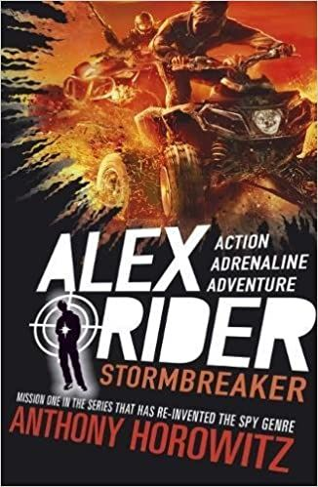
Alex Rider series Anthony Horowitz
In the first book in the number one bestselling Alex Rider series by Anthony Horowitz, fourteen-year-old Alex is forcibly recruited into MI6. But the teenage spy soon finds himself in mortal danger…

https://booksjar.com/pdf-epub-stormbreaker-alex-rider-1-download/

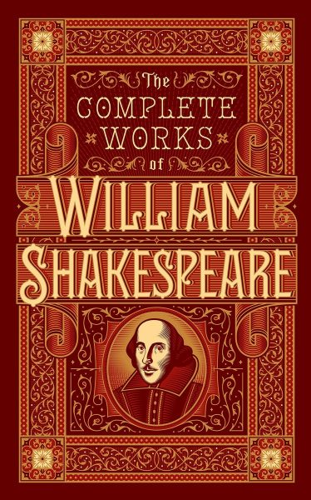
The Complete Works of William Shakespeare
William Shakespeare was an English poet, playwright and actor, widely regarded as the greatest writer in the English language and the world's greatest dramatist. He is often called England's national poet and the "Bard of Avon“. His works, consist of approximately 39 plays, 154 sonnets, two long narrative poems, and a few other verses. His plays have been translated into every major language and are performed more often than those of any other playwright.
Any exposure to Shakespeare before secondary school will be beneficial. All plays and sonnets available through the web link below.

More books for you to enjoy….. You will find these in Scunthorpe Library.

If you like Action and Adventure
Special Forces Cadets by Chris Ryan
Robin Hood by Robert Muchamore
Nightshade by Anthony Horowitz
Strike Lightening by Steve Cole
Never Say Die by Anthony Horowitz
The Lair of the Leopard by Bear Grylls
Earthfall: Redemption by Mark Walden
New Guard by Robert Muchamore

If you like Crime Fiction
The Mystery of the Jewelled Moth by Katherine Woodfine
Ruby Redfort: Pick Your Poison by Lauren Child
Rose Raventhorpe Investigates by Janine Beacham
Nancy Parker’s Diary of Detection by Julia Lee
Jolly Foul Play by Robin Stevens
The Good Thieves by Katherine Rundell
The Highland Falcon Thief by M G Leonard
Letters from the Lighthouse by Emma Carroll

If you like Classics
Little Women by Louisa May Alcott
Ballet Shoes by Noel Streatfield
Around the World in Eighty Days by Jules Verne
The Secret Garden by Frances Hodgson Burnett
Anne of Green Gables by L M Montgomery
The Railway Children by E Nesbit
Little House on the Prairie by Laura Ingalls Wilder
Heidi by Johanna Spyri

If You like Award Winners!
Skellig by David Almond
Buffalo Soldier by Tanya Landman
Millions by Frank Cottrell Boyce
Northern Lights by Philip Pullman
The Other Side of Truth by Beverly Naidoo
A Monster Calls by Patrick Ness
The Graveyard Book by Neil Gaiman

If you like books that are scary…..
The Company of Ghosts by Berlie Doherty
The Nest by Kenneth Oppel
S.C.R.E.A.M. The Mummy’s Revenge by Andrew Beasley
Lockwood & Co: The Screaming Staircase by Jonathan Stroud
Revolver by Marcus Sedgwick
If you like books about friends and family
Library of Lemons by Jo Cottrill
Danger is Everywhere by David O’Doherty
A Boy Called Hope by Lara Williamson T
he Looking-Glass Girl by Cathy Cassidy
Sweet Pizza by G R Gemin
15 Days Without a Head by Dave Cousins

And here are some ideas of activities that you can do:

• Write a book review for students your age • Write a diary entry/blog as your character • Write a letter to the character asking him/her questions about his/her actions and feelings • Devise 10 questions to ask a character. What responses do you think the character would give? • Turn a section of the book into a play script • Create a board game based on the characters/themes/ideas • Imagine the book is turned into a film. Storyboard the main ideas from the book • If the book is turned into a film, which actors would play the characters? Where would it be set? Design/draw the film set as well as draw/design the costumes that the characters would wear • Write down 10 things that you learnt from this book. What else would you like to know? • Write the prequel/sequel • Create a new front page and write the blurb • Create a poster that shows the main things that happens in this book • Draw an outline of 3 main characters and write down what you know about them, use words to describe their personality and appearance • Use a dictionary to find out the meaning of every word you come across that you don’t know. Then get a thesaurus and find alternative words to use for this word • Research the author and create a poster that tells us all about him/her.

Bring any of your work with you and show your English teacher to gain reward points.
Have a great summer and keep reading!
Ms. Graham

